API Docs

Hanafi Naufal

1. Index

Url : <http://127.0.0.1:8000/api/candidates>

Method : GET

Result :

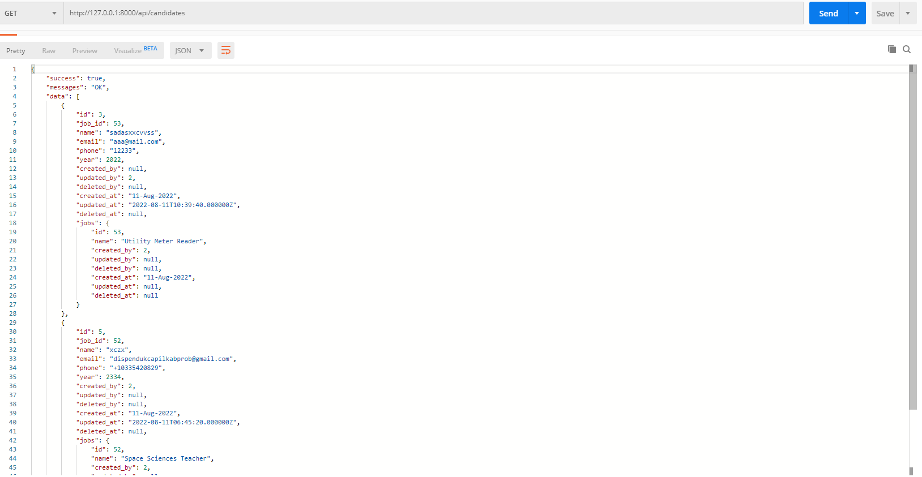

1. Detail

Url : <http://127.0.0.1:8000/api/candidates/3>

Method : GET

Result :

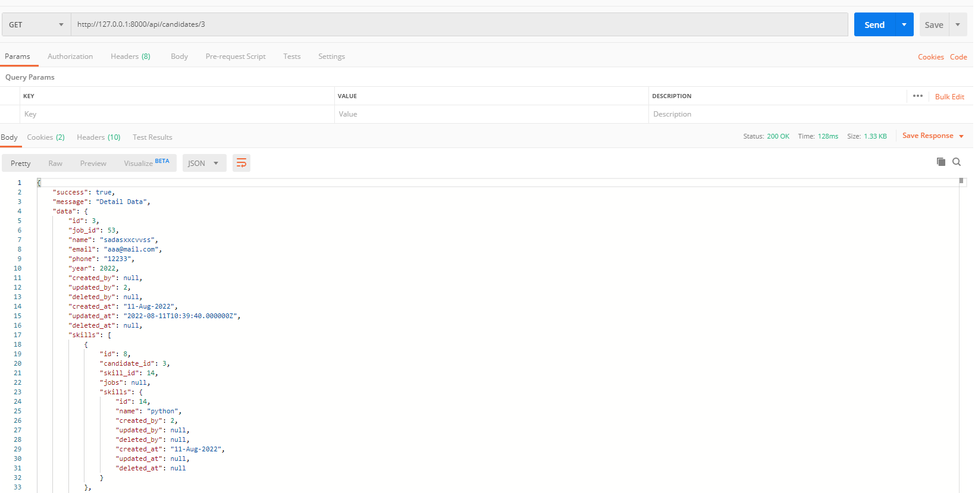

1. Store

Url : <http://127.0.0.1:8000/api/candidates>

Method : POST

Result : 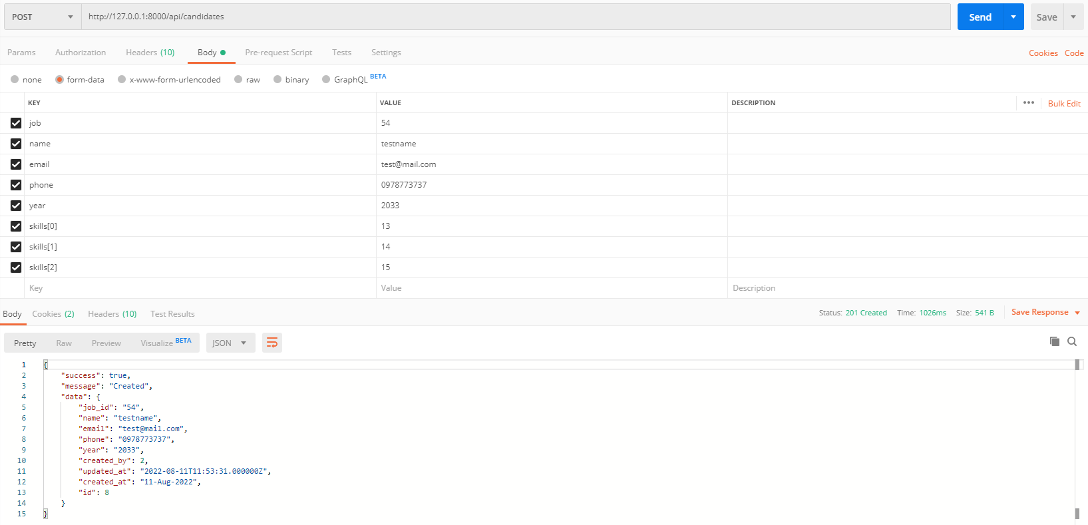

1. Update

Url : <http://127.0.0.1:8000/api/candidates/3>

Method : PATCH

Result :

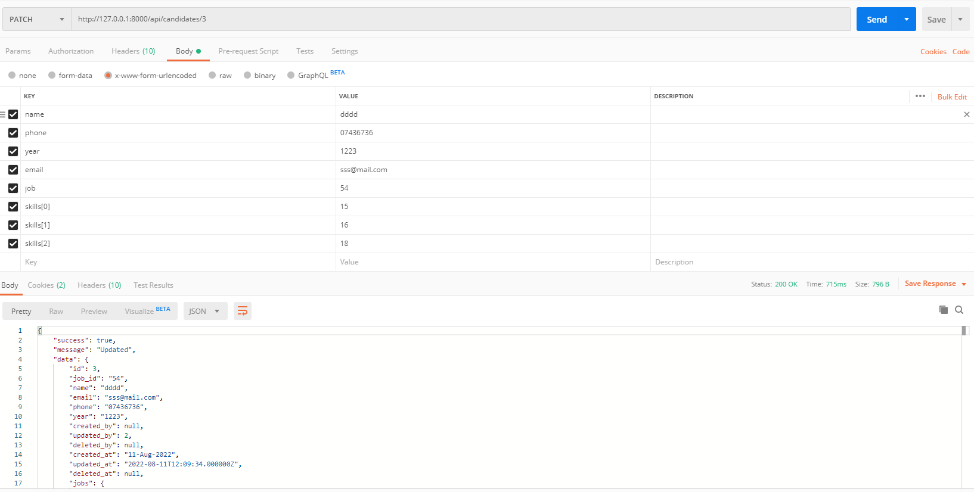

1. Delete

url : <http://127.0.0.1:8000/api/candidates/3>

Method : DELETE

Result :

